Paper Template for ICMC 2021
First Author | Second Author | Third Author
Affiliation1  author1@myorg.org | Affiliation2  author2@myorg.org | Affiliation3  author3@myorg.org

ABSTRACT
The abstract should be placed at the start of the top left column and should contain about 150–200 words. The abstract should be formatted in italic type (this has already been set in the abstract style).

- INTRODUCTION
This template includes all the information about formatting manuscripts for the ICMC 2021 Conference. Please use either MS-Office or LATEX templates when preparing your submission. Please follow these guidelines to give the final proceedings a uniform look. If you have any questions, please contact the ICMC 2021 Organizers.
This template can be downloaded from the ICMC 2021 web site (http://www.icmc2021.org/).
- PAGE size AND FORMAT
The proceedings will be formatted as portrait A4-size paper (21.0cm x 29.7cm). All material on each page should fit within a rectangle of 17.2cm x 25.2cm, centered on the page, beginning 2.0cm from the top of the page and ending with 2.5cm from the bottom. The left and right margins should be 1.9cm. The text should be in two 8.2cm columns with a 0.8cm gutter. All text must be in a two-column format, and justified.
- Typeset Text
  - Normal or Body Text
Please use a 10pt (point) Times font. Sans-serif or non-proportional fonts can be used only for special purposes, such as distinguishing source code text.
The first paragraph in each section should not be indented, but all other paragraphs should be.
  - Title and Authors
The title is 16pt Times, bold, caps, upper case, centered. Authors’ names are centered. The lead author’s name is to be listed first (left-most), and the co-authors’ names after. If the addresses for all authors are the same, include the address only once, centered. If the authors have different addresses, put the addresses, evenly spaced, under each authors’ name.
  - First Page Copyright Notice
Please include the copyright notice exactly as it appears here in the lower left-hand corner of the page. It is set in 8pt Times, one column in width, and should not descend into the page margins (i.e. it should keep clear of the 1" margin at the bottom of the page).
  - Page Numbering, Headers and Footers
Do not include headers, footers or page numbers in your submission. These will be added electronically at a later stage, when the publications are assembled.
- headings
First level headings are in Times 12pt bold, centered with 1 line of space above the section head, and 1/2 space below it. For a section header immediately followed by a subsection header, the space should be merged.
  - Second Level Headings
Second level headings are in Times 10pt bold, flush left, with 1 line of space above the section head, and 1/2 space below it. The first letter of each significant word is capitalized.
    - Third and Further Level Headings
Third level headings are in Times 10pt italic, flush left, with 1/2 line of space above the section head, and 1/2 space below it. The first letter of each significant word is capitalized.
Using more than three levels of headings is strongly discouraged.
- Floats and equations
  - Equations
Equations should be placed on separated lines and numbered. The number should be on the right side, in parentheses.
Copyright: © 2021 First author et al. This is an open-access article dis- tributed under the terms of the Creative Commons Attribution License 3.0 Unported, which permits unrestricted use, distribution, and reproduction in any medium, provided the original author and source are credited.
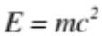 (1)

  - Figures, Tables, and Captions
All artwork must be centered, neat, clean, and legible. All lines should be very dark for purposes of reproduction and artwork should not be hand-drawn. The proceedings will be distributed in electronic form only, therefore color figures are allowed. However, you may want to check that your figures are understandable even if they are printed in black-and-white.

String value | Numeric value
Hello ICMC2021 | 2021
Table 1. Table captions should be placed below the table.
Numbers and captions of figures and tables always ap- pear below the figure/table. Leave 1 line space between the figure or table and the caption. Figure and tables are numbered consecutively. Captions should be Times 10pt. Place tables/figures in text as close to the reference as possible, and preferably at the top of the page.
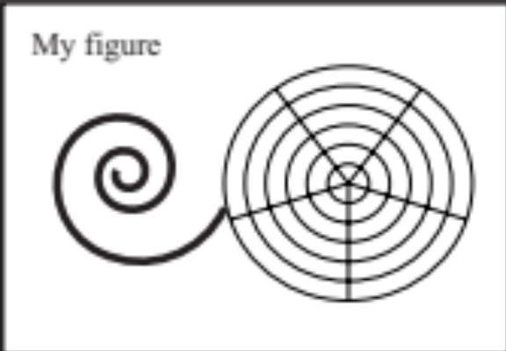
Figure 1. Figure captions should be placed below the figure, exactly like this. Please note that the printed proceedings will be black and white.
Always refer to tables and figures in the main text, for example: see Figure 1 and Table 1. Figures and tables may extend across both columns to a maximum width of 17.2cm.
Vectorial figures are preferred. For example when using Matlab, export using either Postscript or PDF format. Also, in order to optimize readability, the font size of text within a figure should be at list identical to footnote font size. If bitmap figures are used, please make sure that the resolution is enough for print quality.
  - Footnotes
Indicate footnotes with a number in the text. Use 8pt type for footnotes. Place the footnotes at the bottom of the page on which they appear. Precede the footnote with a 0.5pt horizontal rule.

- Citations
All bibliographical references should be listed at the end, inside a section named “REFERENCES”.
References must be numbered in order of appearance. Please avoid listing references that do not appear in the text.
Reference numbers should appear within square brackets, such as in [1] or [2, 3].
The reference format is the standard IEEE one. We rec- ommend using BibTeX to create the reference list.
- CONCLUSIONS
Please, submit full-length papers. Submission is fully electronic and automated through the Conference Management Management System. Do not send papers directly by e-mail.
Acknowledgments
At the end of the Conclusions, acknowledgements to peo- ple, projects, funding agencies, etc. can be included af- ter the second-level heading “Acknowledgments” (with no numbering).
- REFERENCES
- A. Someone, B. Someone, and C. Someone, “The ti- tle of the journal paper,” J. New Music Research, vol. 111, no. 22, pp. 111–222, 2009.
- X. Someone and Y. Someone, The Title of the Book. Springer-Verlag, 2004.
- A. Someone, B. Someone, and C. Someone, “The Title of the Conference Paper,” Proceedings of the 2005 International Computer Music Conference, Barcelona, 2005, pp. 213-218.

This is a footnote.

